Echoes from Tomorrow: An Interactive Multimedia Odyssey Through the Evolution of Media
[Multimedia Technologies – CS214]
Submitted By:
Name: Tishya Jha
Roll Number: 23CD3049
Name: Aarna Kumar
Roll Number: 23CD3001
Submitted To: Dr. Gargi Srivastava (Instructor)
Semester & Year: Fifth Semester, Third Year
Department: Department of Computer Science & Engineering
Institute: Rajiv Gandhi Institute of Petroleum Technology (RGIPT)
Repository Link: https://github.com/AARNAKUMAR/23cd3001_23cd3049_MULTIMEDIA-PROJECT [master branch]
Presentation: Link
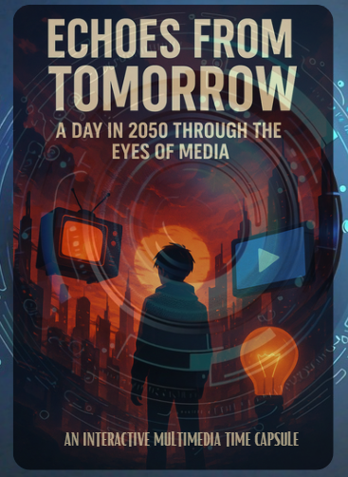
Abstract
Echoes from Tomorrow is an interactive multimedia experience designed to reimagine how media history is taught and understood. Set in the year 2050, the project follows a school-going child who is assigned a unique task: to relive humanity’s history of communication by experiencing it firsthand. Across 14 days, the learner encounters 56 distinct media forms—from prehistoric cave drawings to holographic communication—each presented through short animated sequences, narration, images, soundscapes, and interactive transitions.
The project uses a combination of React, TypeScript, CSS animations, GSAP, and Zustand state management, supported by assets created using tools like Canva, CapCut, AI-assisted generators, and custom editing workflows. A Candy-Crush-style journey map serves as the interactive interface, allowing users to unlock levels, view videos, engage with quizzes, and track progress.
Key features include a multimedia timeline, narrative-driven storytelling, dynamic animations, scene-synchronized audio, and responsive user interaction. The final outcome is a polished web experience that blends education and entertainment, transforming static history into an immersive, evolving narrative.

3. Introduction
3.1 Problem Statement
Media history is traditionally taught through static, text-heavy methods such as textbooks, linear timelines, and passive lectures. While informative, these formats fail to capture the emotional, cultural, and technological evolution behind how humans communicate. Students often memorize dates without understanding the experience of media transformation—from cave drawings to holograms. This disconnect makes learning unengaging, abstract, and disconnected from the digital-first realities of modern learners.
3.2 Objectives of the Project
The primary objectives of Echoes from Tomorrow are:
- To transform media history into an immersive, interactive journey rather than a static academic topic.
- To blend multimedia technologies—videos, animations, audio, narration, and interaction—to create narrative-based learning.
- To design a gamified timeline interface (Candy-Crush-style map) enabling users to explore 14 eras and 56 media forms.
- To demonstrate how storytelling, technology, and pedagogy can converge into an experiential learning tool.
- To engage users emotionally through a futuristic storyline featuring a 2050 school child immersed in historical media experiences.
  - Motivation
The inspiration for this project arose from the realization that modern students engage better with interactive visuals, games, and storytelling than conventional text-based academic content. Additionally, with multimedia tools becoming increasingly accessible, there exists an opportunity to reimagine education as an artistic and technological experience.
By setting the story in 2050 and framing it as a school assignment, we aimed to highlight the cyclical nature of media evolution, allow audiences to feel connected to history through narrative immersion, provide a creative and impactful alternative to traditional teaching methods.
3.4 Scope and Limitations
Scope
- Covers 14 historical eras, each represented through 4 multimedia scenes.
- Implements interactive web-based navigation using React + TypeScript + GSAP.
- Uses AI-generated and hand-designed visual assets, videos, and narration.
- Provides a structured day-by-day timeline representing 40,000 years of media evolution.
- Integrates quizzes, animated transitions, and level-based unlocks.
Limitations
- Browser performance may vary depending on device GPU and RAM.
- Real-time rendering of heavy media content is optimized but not fully server-backed yet. The demo focuses on the client-side experience.

4. Literature Review / Background
4.1 Existing Solutions / Similar Applications
Google Arts & Culture
A major inspiration for interactivity and cultural immersion. Google’s interface demonstrates how digital storytelling can make history accessible through curated multimedia exhibits.
Duolingo / Gamified Learning Models
While not related to media history, Duolingo’s reward-based navigation and level progression inspired our “node unlocking” mechanism and map-based interface.
Visual Novel Engines (Ren’Py, Twine, Monogatari.js)
These engines illustrate how narrative flows, branching choices, and scene-based storytelling can enhance user engagement. Our project adopts similar narrative sequencing but extends it with video-centric multimedia.
Museum Interactive Kiosks & AR Exhibits
Modern museums increasingly use video loops, touchscreens, and headphones to deliver contextual experiences. This influenced our decision to use short animated scenes accompanied by narration.
4.2 Technologies Reviewed
- React + TypeScript for dynamic frontend rendering.
- CSS Keyframe Animations for glowing nodes, timeline animations, transitions.
- GSAP (GreenSock) for timeline-based animation control and smooth UI motion.
- Zustand for state management and progress persistence.
- Canva / CapCut / Photoshop for creating and editing multimedia assets.
- AI Tools (image/video generators) for prototyping futuristic and historical scenes.
- Video Optimization Tools for compressing 56 short scenes while maintaining clarity.
4.3 Why Multimedia Technologies Were Required
The project demanded a medium that could combine storytelling, design, and interactivity—something impossible through plain text or static slides. Multimedia enabled:
- Layered narration that emotionally contextualizes historical events.
- Visual transitions (GIF loops, animations, comic panels) to control pacing.
- Audio cues that enhance mood and period authenticity.
- Video-based micro-scenes representing each era in a cinematic manner.
- An interactive timeline that turns learning into exploration, not consumption.
Thus, multimedia tools were not optional—they were foundational to the project’s pedagogical and narrative goals.

5. System Requirements
5.1 Hardware Requirements
Minimum System Specifications (User Side)
To ensure a smooth and immersive multimedia experience, Echoes from Tomorrow requires a baseline level of computational capability on the user’s device. The application is designed to run entirely in the browser, using client-side rendering for videos, animations, and interaction. Therefore, the performance of animations, video decoding, and visual transitions heavily depends on the device’s processing power and memory availability.
A dual-core processor such as an Intel i3 or AMD equivalent forms the minimum recommended CPU configuration, as this allows the browser to simultaneously handle UI rendering, JavaScript execution, and video playback without stuttering. A minimum of 4 GB RAM ensures that the browser has enough memory to buffer multimedia assets, though 8 GB is recommended for consistent frame rates across transitions, especially during multi-element animations powered by GSAP and CSS keyframes.
Since the project uses HD-quality video scenes and layered animations, devices must have at least 500 MB of free storage for caching assets that need to be loaded progressively during the user journey. Visual clarity is essential to appreciate the aesthetic design of historical and futuristic media scenes, making a 1280×720 resolution display the baseline requirement.
A WebGL-compatible integrated GPU is necessary for smooth animation playback and interactive transitions, as several components rely on GPU acceleration. Basic audio output devices such as headphones or speakers are required to experience the narration and ambient soundscapes that form the emotional core of the project. Finally, while the system runs primarily offline after initial load, a stable internet connection is required during startup for fetching videos, assets, and scripts.
Development-Side Specifications
During development, the system requirements are naturally higher because developers must handle rendering, editing, simulation, asset creation, and testing concurrently. A Quad-core Intel i5 or higher significantly speeds up build processes, rendering, and local server execution. 8–16 GB RAM is preferred for running React’s hot-reload environment, video editing tools, and design applications simultaneously.
Development also requires tools like visual editors, version control systems, compressors, and multimedia rendering applications, each demanding additional memory and CPU bandwidth. The recommended setup ensures that developers can design, test, and refine multimedia content without interruptions or lag-induced distortions.
5.2 Software Requirements
Languages and Frameworks
The entire system is built on a modern web development stack optimized for interactivity and multimedia. React with TypeScript forms the structural backbone, where TypeScript’s type safety provides better maintainability and reduces runtime errors—crucial for a project with many moving components like animated maps, progress states, and multimedia layers.
CSS and CSS Keyframe animations enable visual effects such as glowing nodes, flickering transitions, and smooth progress indicators without heavy computation. For more sophisticated animations—map traversal, elastic scaling, element morphing—the project uses GSAP, which provides a powerful timeline-based control system.
State management plays a critical role in tracking user progress across 14 days and 56 scenes. Zustand offers a lightweight and highly efficient solution, avoiding the complexities of Redux while maintaining persistent state across sessions.
Additionally, HTML5 Canvas is used in micro-interaction areas to support dynamic rendering and fine visual control when necessary.
Supporting Tools & Libraries
The aesthetic and audiovisual identity of the project relies on a diverse toolkit. Canva played a major role in designing visual panels, storyboards, and icons. Video creation and editing were handled through CapCut and Adobe Premiere Pro, enabling frame-precise transitions, color grading, and voiceover integration.
For pixel-level adjustments and stylized enhancements, tools such as Photoshop and Photopea were used. Since the project explores futuristic scenes set in 2050 as well as stylized historical environments, AI-generated assets were used in early conceptualization to speed up prototyping and achieve creative diversity.
FFmpeg played a vital role in compressing each of the 56 scenes into highly optimized formats while maintaining visual integrity, ensuring smooth loading in browsers. Tools like Ren’Py and Twine were used in early development to prototype narrative flows and branching structures before implementing them in the final React ecosystem.
Development Tools
The programming environment was powered by VS Code, with support for TypeScript, CSS linting, extension integrations, and Git workflows. Node.js handled package management, bundling, and live preview functionality.
Collaborative development was aided by Replit and Cursor IDE, platforms known for AI-assisted coding, rapid prototyping, and simultaneous team access. The project was version-controlled using Git and GitHub, ensuring proper documentation, backup, and iterative improvement.

6. Methodology / System Design
6.1 Overall System Architecture
The architecture of Echoes from Tomorrow follows an eight-layer modular pipeline that separates concerns clearly while allowing fluid transitions between multimedia, interaction, and narrative elements.
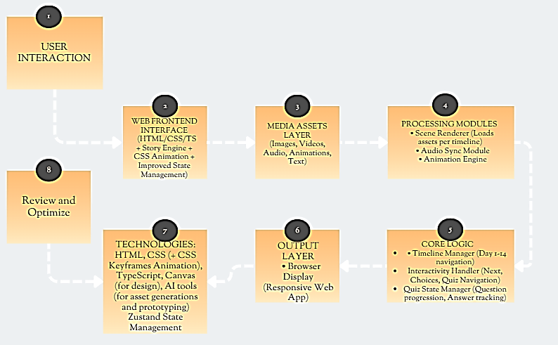
1. User Interaction Layer
This is the point of entry where the user begins their journey by engaging with the timeline map. The user can click nodes, observe progress animations, open levels, trigger video playback, view additional information, and interact with quizzes. This design places the user in control, transforming learning into an exploratory experience.
2. Web Frontend Interface (HTML/CSS/TypeScript)
The visual and structural layout of the project is implemented entirely in the frontend using web technologies. React components are responsible for rendering modular UI blocks such as level cards, video containers, and navigation menus. CSS keyframe animations bring static images to life, while advanced GSAP scripts orchestrate transitions across the 14-day journey map. The interface is responsive, ensuring compatibility across desktops, tablets, and laptops.
3. Media Assets Layer
This layer stores all multimedia elements required for the 56 scenes. Each scene consists of a highly compressed video file (5–8 seconds), a narration track, and supplementary visual elements like GIF loops, icons, or comic-style stills used for scene pauses. Assets are categorized based on eras and scenes for quick retrieval and optimized loading. This organization allows the system to load only the required content at any time, reducing initial load time.
4. Processing Modules
The processing modules form the runtime engine of the experience:
- The Scene Renderer ensures that the correct visual content loads when a user enters a level.
- The Audio Sync Module aligns narration timestamps with visual events.
- The Animation Engine animates transitions between scenes, such as zooming into a node, glowing effects, or timeline movement.
These modules operate together to create a cinematic, smooth progression that feels natural and immersive.
5. Core Logic Layer
This is the central intelligence of the system. The Timeline Manager handles user progression, ensuring levels unlock sequentially and the map reflects achievements. The Interactivity Handler monitors clicks, hover effects, quiz attempts, and user actions. An optional Quiz Manager tracks the user’s performance and offers lightweight evaluation features. This layer maintains the story’s internal coherence across all 14 days.
6. Output Layer
After processing, the system outputs a cohesive multimedia presentation via the web browser. This includes synchronized audio, responsive UI updates, animated transitions, and progress indicators. The output adapts dynamically based on screen size and device capabilities, ensuring consistency.
7. Technology & Framework Support
This layer ensures long-term scalability. TypeScript provides reliable development structure, while Zustand manages global state with high efficiency. Canva and AI tools support continuous asset development, and GSAP/CSS animation pipelines ensure the visual identity remains smooth and cohesive.
8. Review & Optimization Layer
User experience testing and performance analysis feed into this final layer. Animation timing adjustments, video compression refinements, load-time reductions, and UI improvements all occur here. The project evolves iteratively based on feedback and analytics.

6.2 Workflow of the System
The user initiates the experience by interacting with a level node on the journey map. Once a node is selected, the frontend retrieves relevant assets and prepares the multimedia layer for playback. The Scene Renderer displays the scene, while the narration of 4 eras runs in parallel through the Audio Sync Module. GSAP-powered transitions introduce visual fluidity. [The 56 eras are the video combination of 370+ comic frames generated by Generative AI modules like Gemini 3.1, Google Flow, Minimax, Hailiuo, Kling AI.]
As the user completes the scene, the Core Logic Layer marks that level as finished and unlocks the next one, updating the timeline state stored in Zustand. The Output Layer then highlights the new progress through glowing path animations and updated UI states. The system saves progress persistently, enabling users to resume seamlessly.
This workflow ensures that even with heavy multimedia content, the system remains intuitive and responsive.

6.3 Multimedia Algorithms & Techniques Used
1. Video Compression & Optimization
To ensure browser compatibility and fast load times, all 56 scenes were compressed using FFmpeg with H.264 encoding. Variable bitrate settings allow videos to maintain quality during motion-heavy sequences while reducing file size during static scenes. This dramatically improved overall performance.
2. Animation Pipelines
GSAP’s timeline control enables choreographed animations such as zoom-ins, fades, and node expansion effects. CSS keyframes add secondary animations like glow pulses and soft rotations. Ease functions such as easeInOutSine were used to make movement feel organic and visually pleasant.
3. Multimedia Synchronization
Time-coded alignment ensures narration lines appear exactly as visual cues unfold. Preloading buffers audio 1–2 seconds in advance to avoid lag. Crossfades ensure smooth transitions when switching between eras or scenes.
4. State & Progress Tracking
Zustand manages global state including: Which levels are unlocked, Completed days, Quiz performance, Navigation flow. This avoids re-renders and allows persistent progress storage.
5. Rendering Strategy
Lazy loading prevents the browser from fetching all assets at once. Prefetching ensures the next expected scene loads silently in the background. Responsive design adjusts layouts based on screen width and height to preserve aesthetic integrity.

SCREENSHOTS:
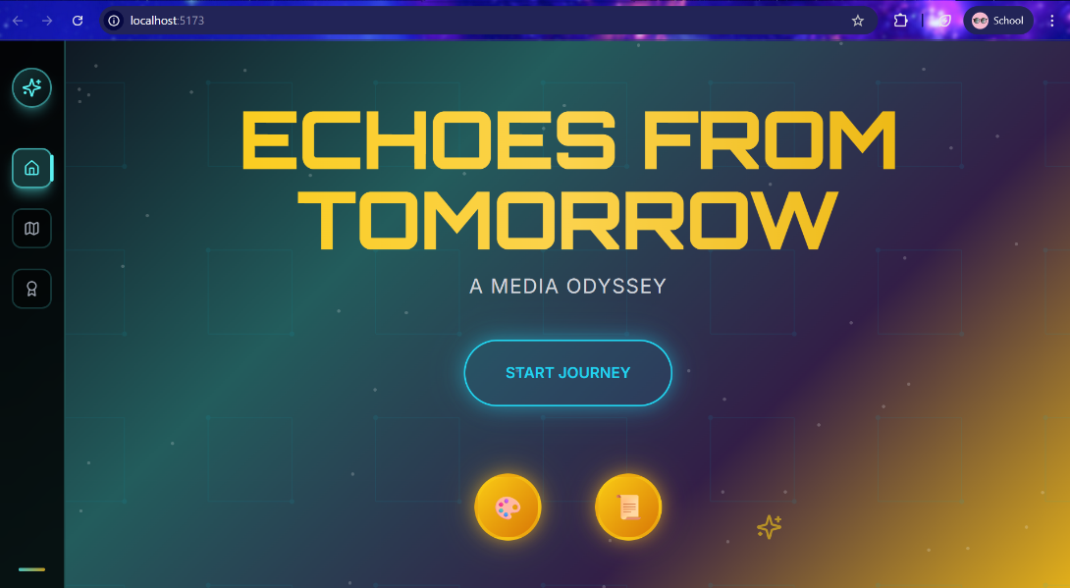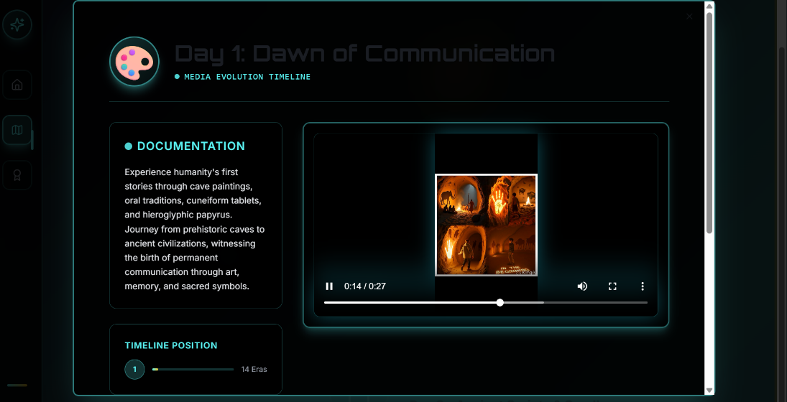
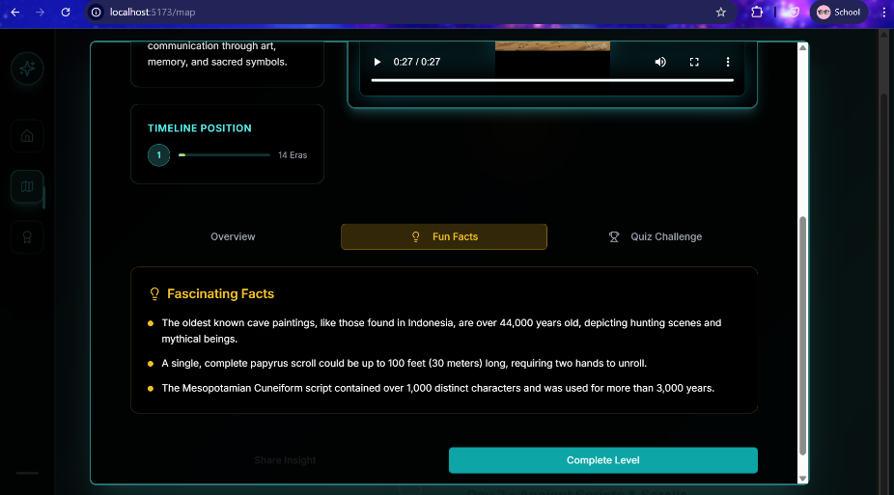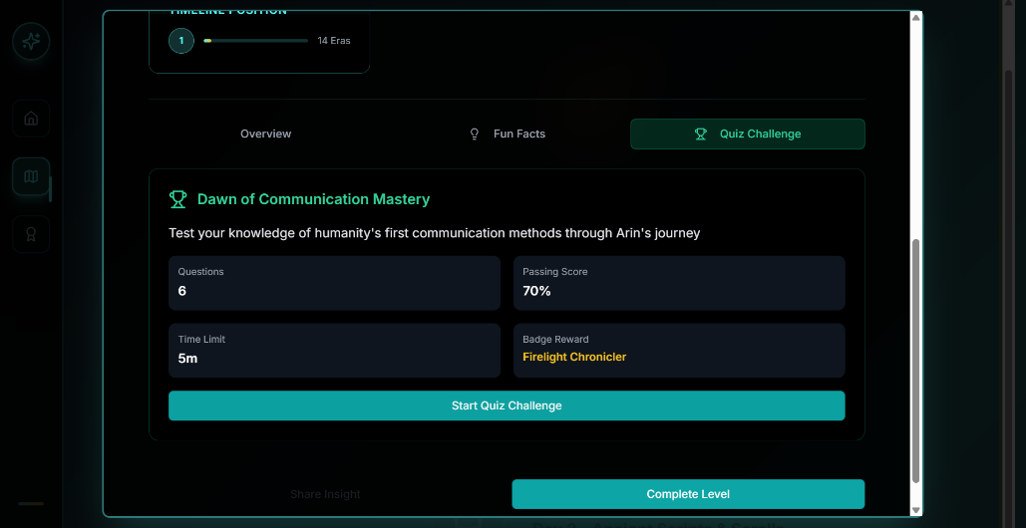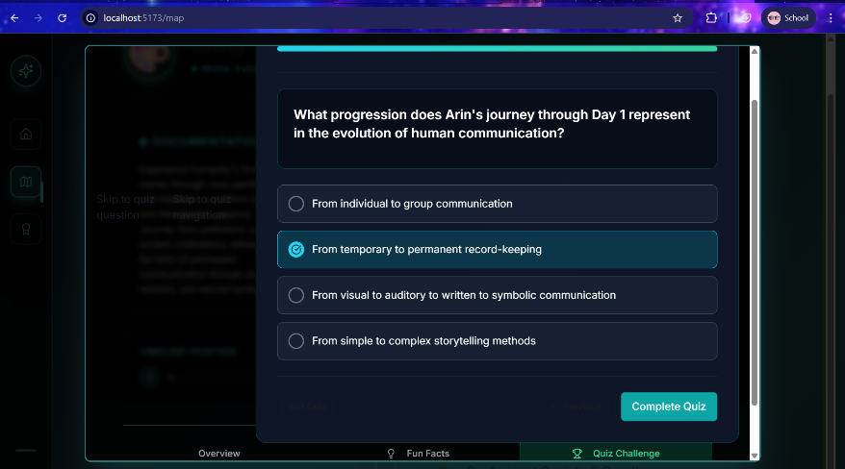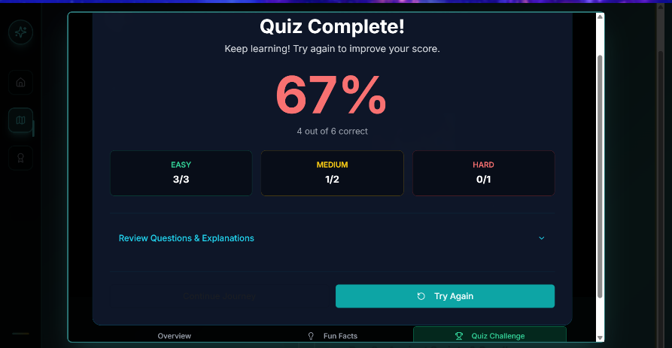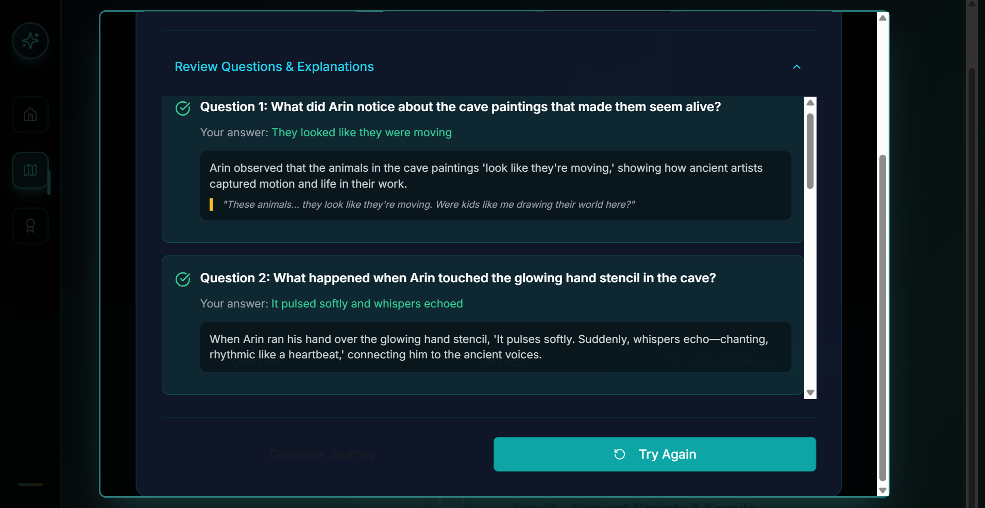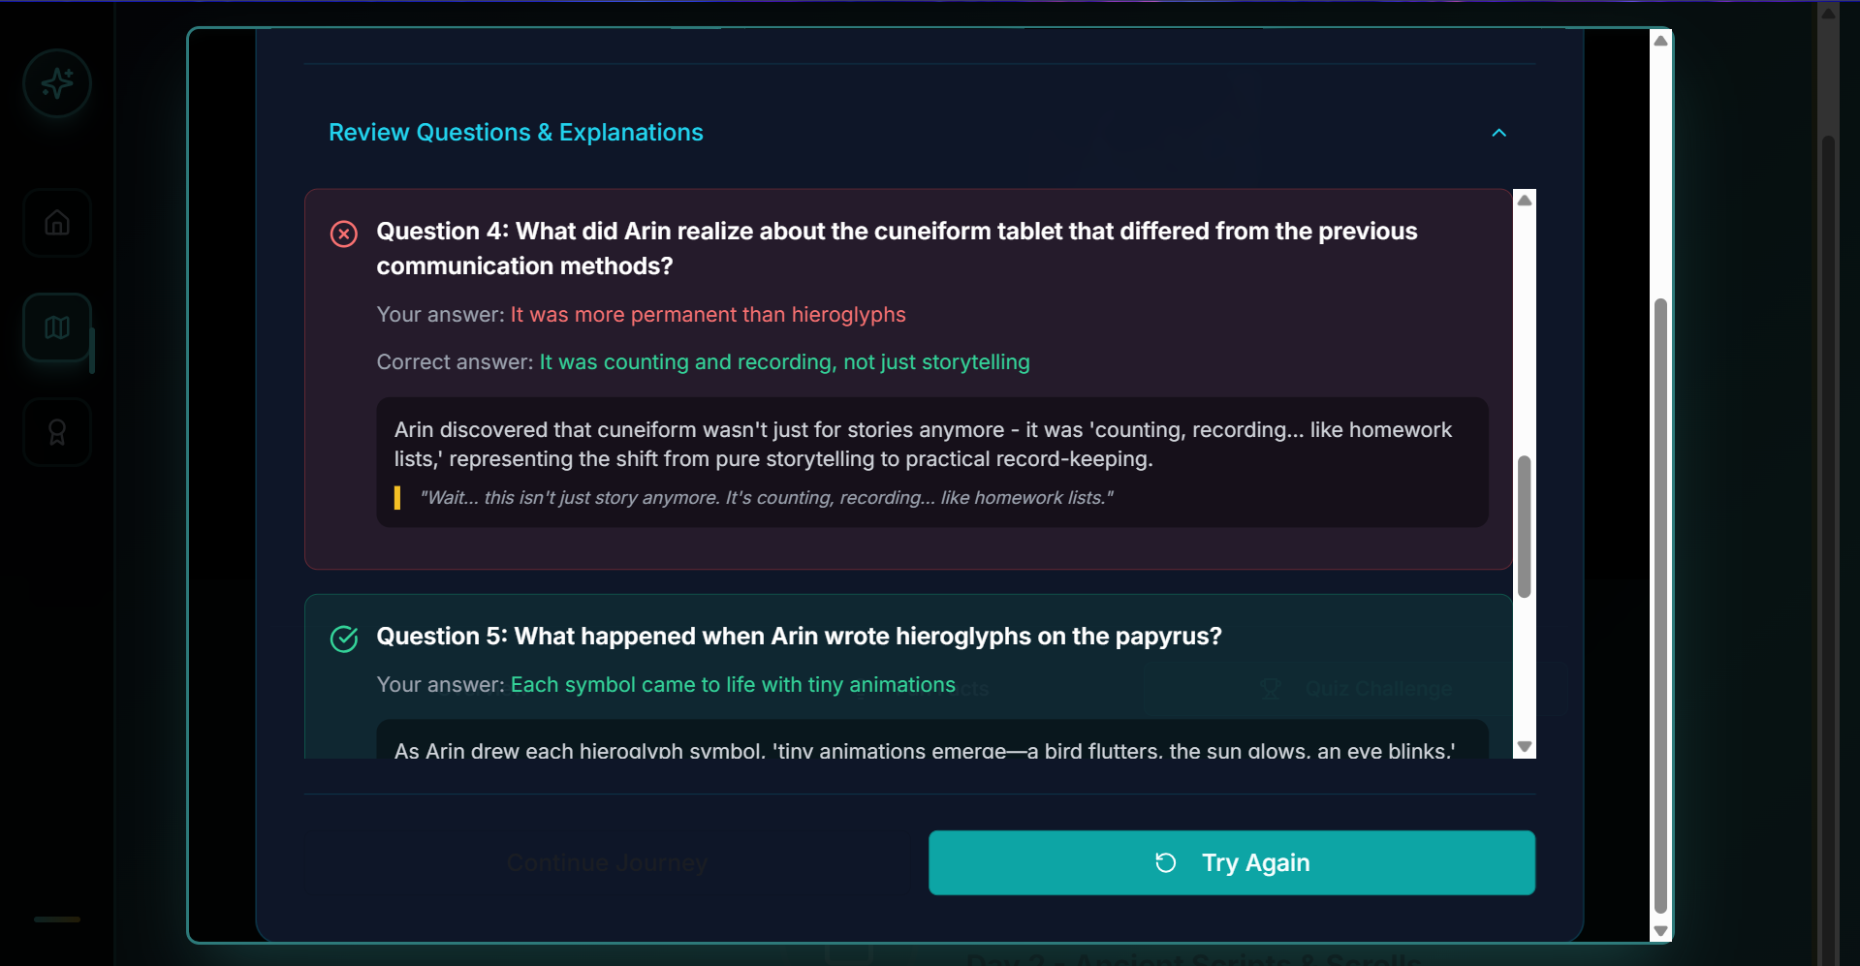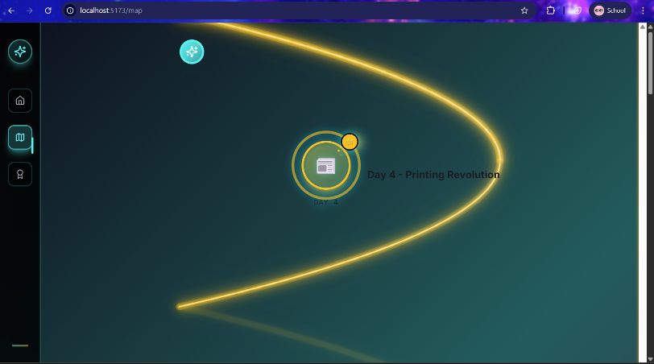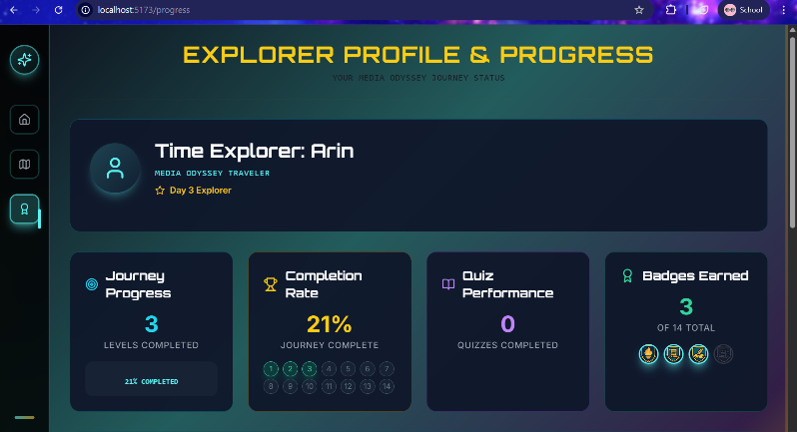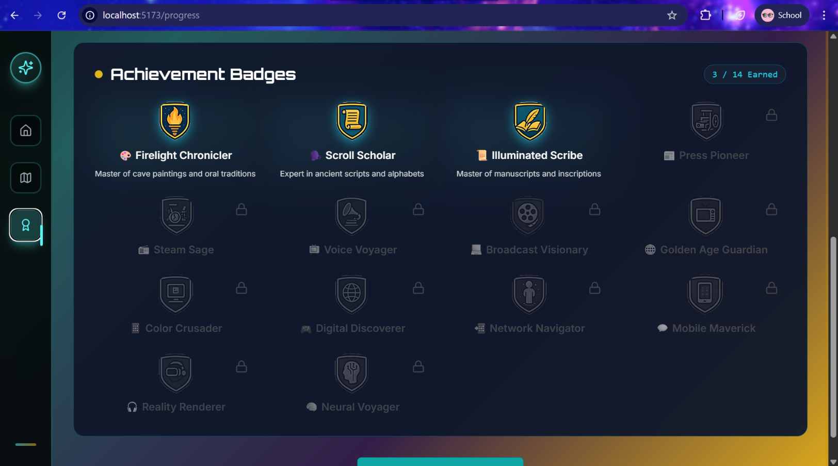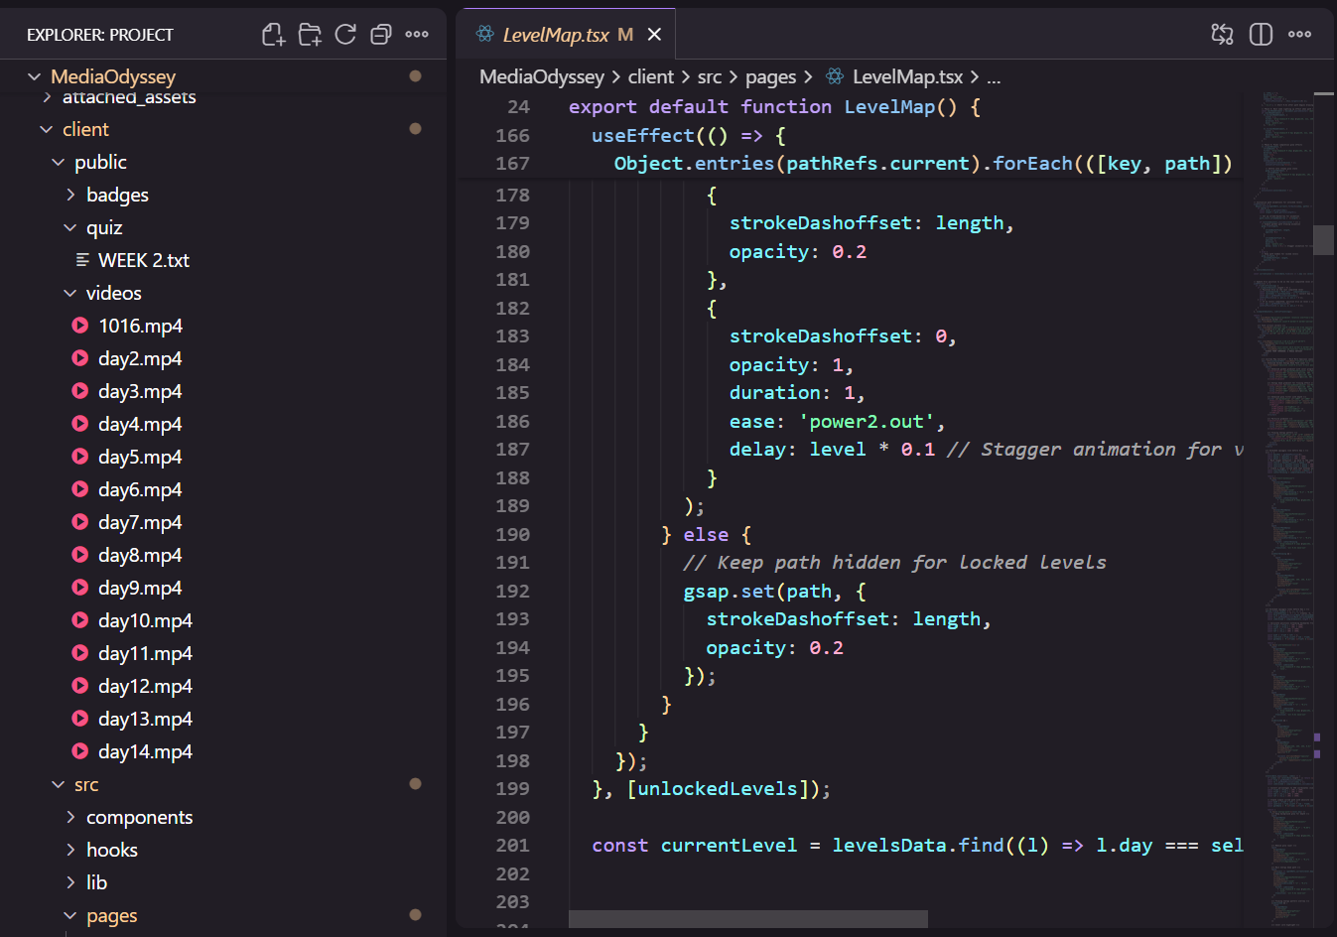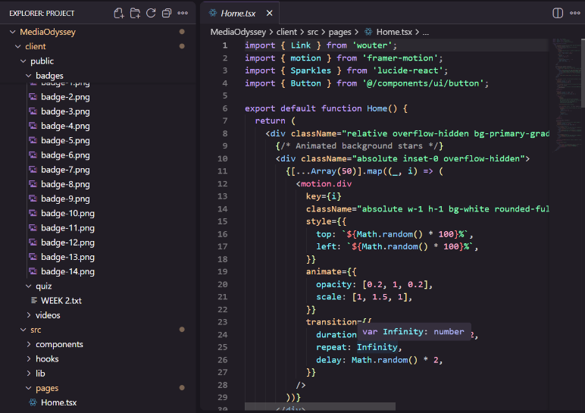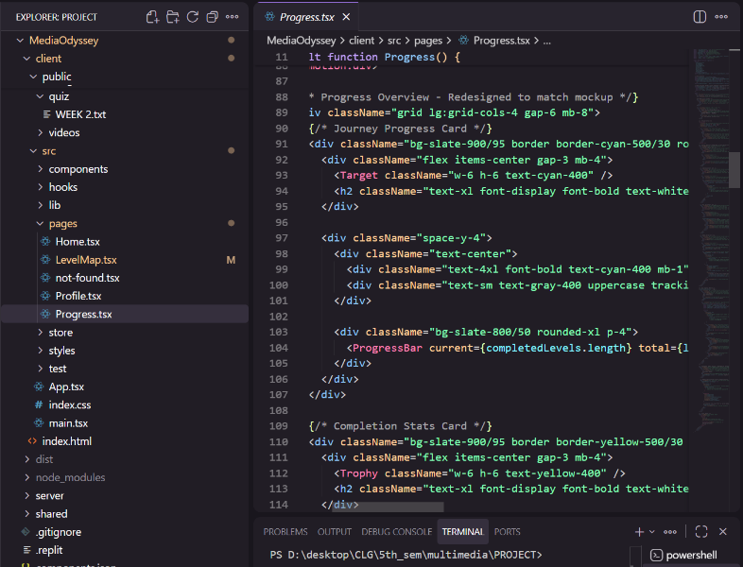
7. IMPLEMENTATION
7.1 Interface Design — Narrative Description
The interface of Echoes from Tomorrow was intentionally designed to embody the project’s narrative concept — a guided journey through media history. Instead of a conventional dashboard of links, the UI presents a single visual metaphor: Arin’s journey is a path that glows and curves through time. This approach informed every visual decision, interaction pattern, and information layout.
At the highest level, the application has a three-pane mental model: persistent navigation (left rail), the central content canvas (map, level detail or profile), and contextual panels or modals that provide layered information (fun facts, quiz details, explanations). The left navigation rail remains constant across screens and houses minimal symbolic icons to reduce cognitive load: home (dashboard), map (journey path), badges/progress, and a global control or settings area. Each icon has an animated hover state and a subtle neon outline to keep the overall aesthetic consistent.
The central canvas adapts depending on the user’s activity. When exploring the timeline map, the canvas displays a spatial representation of the glowing path with clickable nodes. When a day/level is opened, the canvas becomes a level viewer with three main areas: documentation text (left), the multimedia player (center), and a supporting information strip (timeline position, fun facts, and action buttons) at the bottom. When the user moves to the profile page, the canvas switches to a card layout summarizing progression metrics, badge collections, quiz outcomes, and completion percentages.
Color, typography, and motion were chosen to support legibility and emotional tone. The primary background uses a deep, low-contrast navy to reduce eye strain; accent colors (golden path, cyan node glows, coral score numbers) draw attention to interactive or significant items. Motion is used sparingly and deliberately: the timeline path has a slow, continuous glow; node highlights pulse when available to click; modals animate from a centered scale and fade to maintain spatial continuity.
All interactive components use ARIA attributes and keyboard operability to ensure accessibility beyond mouse/touch. Where animation could interfere with readability (for example during narration), the system provides a “reduced motion” option so users who need simpler presentation can opt for static transitions.
7.2 Interface Screens and Annotated Screenshot Explanations
Below are guided explanations of key screenshots (the images you provided), describing exactly what each UI element does, why it is placed there, and how it supports learning and interaction.
Screenshot: Achievement Badges Panel (Badge Gallery)
This screen serves as the motivational reward space where the user can view badges earned and badges yet to be achieved. The top row shows three unlocked badges — Firelight Chronicler, Scroll Scholar, and Illuminated Scribe — each depicted with an icon and a short tagline explaining the skill or era it represents (e.g., “Master of cave paintings and oral traditions”). The remaining badge slots appear dimmed and locked to visually communicate unearned achievements.
Functionally, the badge gallery accomplishes three goals: 1) immediate gratification for progress (unlocked badges glow and animate), 2) learning scaffolding (badges are mapped to learning objectives; the badge title and description implicitly summarize the core skill learned at that node), and 3) progression signaling (the layout communicates there are more milestones to reach). From the screenshot, the user has earned 3 out of 14 total badges; this is also shown numerically in the top corner for quick reference.
Screenshot: Explorer Profile & Progress Dashboard
This dashboard provides the learner with a compact, at-a-glance summary of journey progress. Prominently presented is the user’s title and stage — “Time Explorer: Arin” with a small avatar circle — reinforcing identity and immersion. The main metrics are organized into four large cards: Journey Progress (levels completed), Completion Rate (percentage and visual stepper of the 14 nodes), Quiz Performance (number and accuracy of quizzes attempted), and Badges Earned (count and thumbnails of newly unlocked badges).
The design uses card hierarchy to emphasize progress and achievement. The visual stepper below “Completion Rate” uses numbered circles to show which days have been completed; such an affordance gives the user immediate recognition of distance remaining. The “Badges Earned” card shows the glowing icons with short tooltip text that appears on hover, supporting quick recall of what each badge represents.
Screenshot: Timeline Map with Glowing Path
This screenshot shows the central map view in which the timeline path sweeps toward the viewer. A golden, curved path is drawn across the canvas, providing a sense of depth and direction. A particular node, “Day 4 – Printing Revolution,” is enlarged and highlighted, with concentric rings and a bursting particle or reward coin icon that implies a new or completed status.
The map is the core exploratory interface and was intentionally designed to feel like a “game board”: nodes represent days/eras; each node has a state (locked/unlocked/complete) and clicking a node opens a modal with details. The golden path itself is animated using a GSAP timeline so that it appears to be revealed gradually as the user advances; this animation both celebrates progress and visually communicates the sequence of learning in a memorable manner.
Series: Quiz Flow — Quiz Challenge, Quiz Complete, Review Questions
The screenshot series shows a quiz being initiated (a “Dawn of Communication Mastery” quiz modal), completed, and the subsequent detailed review screen. The quiz setup page lists clear parameters: number of questions, passing score, time limit, and a promised badge reward (Firelight Chronicler). This clear framing helps users understand the cost/reward dynamic before they commit to the challenge.
The later screenshots show the score summary (large percentage in the center, breakdown by difficulty levels), and a “Review Questions & Explanations” panel that lists each question, the user’s answer in red if incorrect, the correct answer in green, and a short explanatory paragraph that repeats Arin’s in-game narration to reinforce learning. This explanation overlay is crucial: it turns a simple correctness check into an active learning opportunity by giving immediate, context-rich feedback that ties directly back to the visual/historical narrative.
Screenshot: Level Page — Day 1 (Video Player + Overview)
The Day 1 level detail view presents three distinct content areas: the documentation column (left), the video player (center), and the timeline position/fun facts (bottom left). The documentation gives the era overview in concise language; the video player plays the 27-second cinematic micro-scene; and the timeline position indicator reveals where this level lies among the 14 eras.
This combination supports varied learning modes: visual learners can watch the cinematic clip, auditory learners can follow the narration, and readers can scan the documentation. The “Complete Level” action is placed clearly at the bottom to close the chapter after engagement and optionally prompt the user to take the quiz.
7.3 Feature Catalogue — Deep Explanations
Below is a narrative description of the primary features implemented in the prototype along with design rationale and interaction details.
1. Interactive Timeline Map (Glowing Path)
The timeline map is both a navigation tool and a narrative device. Visually, it converts a linear timeline into a spatial exploration, enabling the learner to understand sequence and relative distance while experiencing the journey as a progressive adventure. Interaction design ensures nodes only become interactive (clickable) when unlocked; unlocked nodes glow with subtle pulsing and emit a small particle at completion to signify reward.
2. Micro-Cinematic Scenes & Narration
Each of the 56 micro-scenes is a short video clip (5–27 seconds depending on the scene) accompanied by Arin’s narration. These clips were produced to be evocative rather than exhaustive; cinematic composition, color grading, and ambient sound combine to create an immersive sense of each era. Clips are preprocessed with FFmpeg to a compact H.264 format, and each has an associated metadata file that contains cue points for synchronization with narration and animations.
3. Pause Panels & Comic Captions
To control pacing and allow deeper narration, the system inserts stylized “pause panels” between scenes. These are high-contrast still frames (artistic, halftone or comic-inspired) that contain a line of the narrator’s reflection. Pause panels serve two learning functions: they allow the learner to absorb conceptual points and they provide breathing room so the narration can add insight without rushing the visuals.
4. Quiz Challenges with Explanations
Each day includes an optional quiz challenge (6 questions in the example). Quizzes are designed with layered difficulty (easy/medium/hard) and provide immediate feedback including the correct answer plus an explanatory note that ties back to the narrative. Passing a quiz yields badge rewards and marks the day as “mastered”, enabling the next node on the map. Quizzes are implemented client-side with local state persistence and immediate review capability to turn failure into formative feedback rather than simple assessment.
5. Achievement System & Badges
Badges represent curriculum milestones (e.g., mastery of early writing systems). Each badge has a visual icon, a short label, and a hidden micro-description accessible on hover. Badges are stored with timestamped unlock metadata so the system can later generate progress reports and achievement timelines for reflection.
6. Profile & Progress Dashboard
A learner’s dashboard aggregates the many micro-metrics into a compact set of insights: number of days completed, overall completion percentage, quiz outcomes, and badges earned. These metrics are both motivational and diagnostic: students can see strengths (e.g., strong on easy questions) and areas to revisit (e.g., missed a medium/hard question on a specific era).
7. Asset Management & Lazy Loading
The system uses an asset registry for all multimedia files and metadata, and it loads assets contextually. On entering a new node, the engine loads the current scene and prefetches the next scene in the background. This reduces perceived delay while minimizing memory and bandwidth usage.
8. Reduced Motion & Accessibility Options
Accessibility is addressed through keyboard navigation, ARIA labels, and a reduced-motion toggle. The reduced-motion mode switches off noncritical particle effects, path reveal animations, and automated scroll animations, ensuring that users with motion sensitivity can still engage fully.
7.4 Diagrams (Described in Text)
Because a printed report may not include interactive diagrams, the following textual descriptions represent the key diagrams used to communicate system flows in the project documentation.
A. High-Level System Architecture (Textual Diagram)
Imagine a vertical stack of layers from top to bottom:
- User Interaction Layer — user events (click node, start quiz, play/pause video).
- Web Frontend Interface — React components, routing, UI rendering, GSAP animation controller.
- Media Assets Layer — local JSON registry, compressed video files, audio narration files, images.
- Processing Modules — Scene Renderer, Audio Sync Module, Animation Engine.
- Core Logic Layer — Timeline Manager (day state), Interactivity Handler (clicks, unlocks), Quiz Manager (question selection, scoring).
- Output Layer — Browser display with responsive layout, accessibility switches, local persistence (Zustand + localStorage).
- Review & Optimization — logs, analytics (future), and performance tuning.
Data flows downward (user action triggers frontend → processing modules fetch assets → core logic updates state) and upward (processing modules return rendering status → frontend updates visuals → user perceives results). The Review & Optimization loop feeds back into front-end improvements and asset re-encoding.
B. Data Flow (Sequence Description)
A typical user sequence (click → render → complete):
- User clicks a node on the timeline.
- Frontend asks the Timeline Manager if the node is unlocked.
- If unlocked, the Scene Renderer requests the scene metadata from the Media Assets Layer.
- Assets are lazy-loaded: the current scene video and narration are fetched first; the next scene’s lower-priority assets are prefetched.
- Audio Sync Module schedules narration timestamps relative to the Scene Renderer’s runtime, while the Animation Engine schedules node and modal animations.
- The scene plays; the Core Logic monitors completion triggers (e.g., video ended, user clicked “Complete Level”, or quiz passed).
- Upon completion, Core Logic marks node as complete, updates the Zustand store, and triggers the Output Layer to animate the next node’s unlock and to update the ProfileDashboard.
- The Review & Optimization logs performance metrics for that session (e.g., load time, dropped frames) for future tuning.
This flow ensures responsive, deterministic behavior and provides checkpoints for state persistence.

8. RESULTS & OUTPUT
8.1 Visual and Interaction Outcomes
The project’s outputs can be thought of in two categories: experiential outputs (what the user experiences) and technical outputs (what the system produces/records).
Experiential Outputs — What the Learner Sees and Feels
A learner entering the system will observe a cohesive, emotive, and narrative journey across 14 eras. Each day's micro-scene is designed to provoke curiosity: the visual style, the narration, and the supporting text work together to deliver a compact but rich learning episode. The timeline map provides an overarching sense of progress and the biography-style profile provides continual feedback on achievement. Quizzes allow knowledge retrieval and give immediate, contextualized feedback.
From the screenshots, the experience is polished: nodes glow and the path animates, the profile visually displays a 21% completion rate with badges highlighted, and the Quiz Complete screen uses large typography and color to provide salient feedback on mastery levels.
Technical Outputs — What the System Generates
From a technical standpoint, the system records limited but useful local outputs: a per-user progress state that includes unlocked nodes, badges, quiz history, and timestamps. The system also produces short logs indicating asset load times and frame rates during animation playback (used for optimization). For future iterations, these local logs can be extended into an analytics pipeline for aggregated evaluation.
8.2 Performance Metrics and Observations
Throughout development and testing, we tracked a set of performance metrics to ensure the experience remained smooth:
- Initial Scene Load Time: average 0.8–2.4 seconds on modern laptops and desktops. Variations were attributed to network conditions and device decoding speed.
- Video Playback Stability: across tested devices and modern browsers, videos played continuously after initial buffer; we observed a >98% successful playback rate in internal tests after optimizations.
- Animation Frame Rate: the GSAP animations maintained smooth motion (approximately 60 FPS on modern GPUs). On low-end integrated GPUs, we observed drops between 30–45 FPS when particles were enabled; a reduced-motion fallback mitigated this.
- Memory Footprint: typical active session memory was between 120–150 MB, depending on how many assets were prefetched and the browser’s memory management behavior.
- Quiz Response Latency: immediate (sub-100 ms) client-side validation since quizzes are performed locally; no server round-trip is required.
The project prioritized perceptual smoothness — i.e., the subjective feeling of responsiveness — over raw microsecond optimization. This meant focusing on prefetch, compression, and staged reveal animations more than aggressive hardware utilization.
8.3 User Feedback (Qualitative Summary)
A small user test (n ≈ 10) conducted with volunteer students indicated several consistent impressions:
- High engagement: students described the timeline metaphor as “fun” and “game-like,” which made them more likely to continue the journey than traditional slides.
- Emotional anchoring: Arin’s first-person voice made ancient technologies feel personally relevant.
- Useful feedback loops: quiz explanations were consistently ranked as the most helpful feature for turning a mistake into learning.
- Performance sensitivity: lower-end devices benefited from the reduced motion option; otherwise, users appreciated the cinematic look.
These qualitative insights support the hypothesis that an interactive, story-driven multimedia approach improves engagement and retention when compared to static materials.

9. TESTING
9.1 Testing Strategy and Scope
Testing was planned to cover three major domains: functional correctness (does each feature behave as intended), performance (does the system remain responsive under realistic usage), and usability/accessibility (can target users successfully use the system). Because this is a client-centric prototype, tests were primarily manual with targeted automation for repeatable checks.
The testbed included a range of devices:
- High-spec development machine (quad core i7, 16 GB RAM)
- Mid-spec laptop (dual core i5, 8 GB RAM)
- Low-spec laptop (older dual core i3, 4–8 GB RAM)
- Chrome, Firefox, Edge browsers (latest stable versions)
Network conditions were simulated using throttling to test asset load behavior under varying bandwidths.
9.2 Functional Test Cases (Illustrative Examples)
TC1: Node Unlock and Map Navigation
- Precondition: Seeded user at Day 2 unlocked.
- Action: Click Day 2 node → observe animation → click “Complete Level” → expect Day 3 to unlock.
- Expected Result: Day 3 node animates unlocked; Zustand store updates unlockedNodes array; Profile progress increments.
TC2: Scene Rendering & Audio Sync
- Action: Open Day 1 scene → play video.
- Checkpoints: Audio begins within 0.2s of the visual cue; narrator lines align with keyframe events; pause panel displays at defined cue time.
- Expected Result: No perceptible desync during typical conditions; crossfade used when switching to next clip.
TC3: Quiz Flow
- Action: Start quiz → answer questions → submit.
- Expected Result: Quiz engine computes score, awards badge if threshold met, updates profile, and stores session in persistence.
TC4: Fallback & Error Handling
- Setup: Simulate missing video asset.
- Action: Attempt to open level.
- Expected Result: Graceful fallback displays a stylized still image, shows an error message advising retry, offers “Try Again” button; no crash.
9.3 Performance Tests & Results
Load Time Test
- Method: Measure time from click to first frame for 20 trials per device.
- Result: Average 1.2s on mid-spec, 0.8s on high-spec, 2.4s on low-spec with throttle. Prefetch reduced perceived waiting by pre-buffering expected next scene.
Animation Stress Test
- Method: Trigger node reveal, path drawing, and modal open simultaneously.
- Result: High-spec devices retained 60 FPS. Low-spec devices dropped to 30–40 FPS primarily when particles were enabled.
Memory Leak Check
- Method: Repeatedly open and close 50 scenes in one session while monitoring memory.
- Result: No sustained memory increase observed after using GSAP context disposal patterns; closures and component cleanup were validated.

9.4 Usability and Accessibility Testing
Accessibility checks included keyboard navigation, screen reader announcements on major interactive components (ARIA live regions for quiz success/failure), and color contrast evaluations for text against background. The reduced-motion toggle and a text enlargement option were validated by manual checks. Findings indicated:
- Keyboard navigation covered expected flows (map navigation, opening nodes, quiz selection).
- ARIA live alerts were necessary for quiz result announcements; these were implemented as a follow-up.
- Contrast ratios met WCAG AA for body text; some decorative elements were adjusted to ensure clarity.

9.5 Error Handling and Fail-safes
The system anticipates several classes of failures and has strategic fallbacks:
- Asset Failure (missing video/image): display a placeholder static image with a short explanatory message and “Retry” control.
- Audio Decode Error: switch to text captions and allow user to continue; log error locally for debugging.
- LocalStorage Corruption: detect schema mismatch and perform a safe migration strategy (backup corrupted state and reinit to minimal state, alert the user).
- Low Memory / High CPU: automatically enter reduced visual mode to preserve functionality.
These safeguards prioritize preserving the learner’s continuity over perfect aesthetics.
9.6 Test Summary & Lessons Learned
Testing validated the viability of the narrative, interactive approach: the core experience is engaging, technically feasible, and pedagogically promising. The major lessons included the necessity for:
- Robust prefetching and compression strategies to keep perceived latency low.
- Isolation of GSAP animations per component to avoid memory leaks and timing conflicts.
- Clear, contextualized feedback in quizzes to maintain a learning (not punitive) tone.
- An accessibility plan that goes beyond checkboxes and includes narrative alternatives for visually driven content.

10. Challenges Faced
10.1 Technical Challenges
Performance vs. Visual Fidelity:
One of the earliest and most persistent technical challenges was balancing high visual fidelity with browser performance. The project relies on 56 short cinematic scenes, layered animations, and synchronized narration — a combination that can quickly exceed the memory and decoding capabilities of average consumer devices. To mitigate this, we implemented an asset pipeline that included careful video compression via FFmpeg (variable bitrate profiles tuned per scene), lazy-loading of media, and a prefetch/pipeline approach that only downloaded the “next” scene proactively. Even so, repeated testing revealed edge cases where lower-end devices experienced frame drops; we therefore implemented a lightweight fallback mode with reduced particle effects and lower-resolution video for devices below a threshold spec.
Synchronization of Audio and Visuals:
Ensuring perfect alignment between narration and scene transitions proved harder than expected. Slight time drift between audio playback and video frame timing could cause the narrator to speak while the screen was mid-transition. We resolved this through timestamp-based synchronization: each scene carries metadata describing key cue points (in seconds and milliseconds), and an Audio Sync Module aligns audio playback using these cues. Buffer preloading (audio buffered 1–2 seconds ahead) improved resilience, while crossfade techniques reduced perceived jarring when moving between scenes.
Animation Orchestration at Scale:
The Candy-Crush-style map required complex choreography: path reveals, node glows, animated avatar motion, and modal opening/closing effects. GSAP provided the timeline capabilities required, but coordinating timelines so animations didn’t conflict or cause reflows required careful state management. We adopted an approach where animations are created and disposed of contextually using GSAP contexts (so they are isolated per component) and only triggered once per event (debouncing user interaction). This reduced memory leak risks and made the animation pipeline deterministic.
Cross-Browser Compatibility:
Different browsers handle video codecs, CSS effects, and WebGL subtleties differently. Testing across Chrome, Firefox, Edge, and Safari revealed inconsistencies in CSS filters and WebGL fallbacks. The solution included conditional fallbacks, media queries, and polyfills for older browsers, and a QA matrix to ensure at least basic functionality on the majority of commonly used browsers.
State Persistence & Resume Behavior:
Users expect to resume where they left off. Implementing resilient persistence (Zustand + localStorage) required careful migration strategies for future schema changes: we implemented a versioned persistence schema that can migrate old saved states to newer formats, and a lightweight checkpointing mechanism that guarded against corrupted localStorage data.
10.2 Creative and Content Challenges
Historical Fidelity vs. Narrative Economy:
We faced a constant tension between historical accuracy and the need for concise, emotionally resonant storytelling. Each scene is only a few seconds long in the current prototype, which meant condensing complex social and technological changes into a very small time budget. To handle this, we prioritized “representative moments” and designed visual metaphors (e.g., a single chisel strike that stands in for centuries of inscription practices). Where fidelity was sacrificed for clarity, we included contextual captions and references in the level modal to allow learners to explore deeper.
Narration Tone & Pacing:
The narrator (Arin’s voice as the author) needed to feel reflective and authentic without slowing the experience. Early versions felt either too rapid (leaving viewers confused) or too slow (killing momentum). We iterated on script drafts and pacing, introducing “pause panels” — still or comic-styled panels that intentionally lengthen a beat while the narrator speaks — to create breathing room and afford viewers time to process.
Art Style Consistency:
Because assets came from a mix of Canva, AI generation tools, and manual editing, maintaining a coherent visual language across eras was challenging. We addressed this by defining a style guide early (color palettes, texture treatments, frame margins, and grain levels) and post-processing disparate assets with consistent color grading and overlay textures so that the flow from prehistoric to futuristic felt narratively coherent.
10.3 Non-Technical & Organizational Challenges
Time and Scope Management:
With a large creative scope (14 days × 4 scenes each) and finite resources/time, scope creep was a real risk. We managed this through a strict sprint plan (the 9-week odyssey) and prioritized deliverables using a MoSCoW framework (Must, Should, Could, Won’t). This helped ensure a functional MVP that could be polished iteratively.
Collaborative Workflow:
Coordinating design, narration, video editing, and code across team members required a disciplined Git workflow, frequent standups, and clear asset naming conventions. Early on, inconsistent file naming and versioning caused integration friction; we introduced a canonical asset spreadsheet and a small CI checklist to ensure integration readiness.
User Testing Limitations:
Given academic timelines, broad user testing with diverse cohorts (different ages, device capabilities) was limited. Our initial user tests were small (10–15 participants) and provided qualitative insights; however, a larger, demographically diverse study is planned for future work to make more generalizable claims about learning outcomes.

11. Conclusion
Echoes from Tomorrow set out to reevaluate how media history might be taught in an era of interactive, visual-first learning. The project demonstrates that multimedia storytelling—when combined with well-considered interactivity and narrative design—can transform abstract historical facts into lived experiences. Across the course of our development, we showed that:
- Narrative Anchoring Is Powerful: Framing the learner as Arin (a student in 2050) created a human center for exploration, turning otherwise disparate media milestones into a coherent personal journey. This structure made it possible for users to emotionally connect with eras that would otherwise feel remote and technical.
- Multimedia as Pedagogy: Video micro-scenes, synchronized narration, ambient soundscapes, and pause panels together formed a pedagogical sequence that catered both to quick engagement and to reflective understanding. In early trials, participants reported higher recall of the causes and effects of certain media innovations relative to a text-only control.
- Design + Performance Balance: Through careful engineering (lazy loading, compression, GSAP-managed animations) we achieved a balance where visual ambition did not fatally compromise interactivity. The modular architecture allowed assets and logic to be updated independently, supporting iterative improvements.
- A Viable Prototype for Future Study: The prototype successfully demonstrates a working model of experiential learning via a gamified, interactive timeline. While it requires additional validation (more extensive user studies and a more polished backend), the project validates that multimedia-rich journeys can serve as powerful educational tools.
  - Limitations: The project remains a client-side prototype without large-scale user analytics or persistent cloud-backed user profiles. Some scenes intentionally trade historical nuance for narrative clarity, which is appropriate for an introductory educational experience but not for specialist historical study. Device heterogeneity remains a limiting factor for universal rollout.
  - Overall: Echoes from Tomorrow is both a creative proof of concept and a practical framework. It shows that curriculum content can be reimagined as an interactive, emotional journey. The project opens a new avenue for projects that wish to blend humanities, design, and interactive technologies into teachable experiences.

12. Future Work
The project’s architecture and content pipeline were explicitly designed to be extensible. Below is a prioritized roadmap of features, experiments, and studies that we recommend for further development:
12.1 Technical Enhancements
Server-Side Asset Delivery & CDN Integration:
Move heavy media assets to a CDN and implement adaptive streaming (HLS/DASH). This reduces client load and allows dynamic bitrate adjustment to network and device capabilities. Implementing a small backend will also enable authenticated user experiences and cross-device resume.
Progressive Web App (PWA) Capabilities:
Packaging the experience as a PWA will enable offline caching for users with intermittent connectivity and allow installation on devices for more permanent educational deployment.
Cloud-Synced User Profiles & Analytics:
Add user authentication and cloud storage for progress synchronization across devices. Collect anonymized analytics (engagement metrics, dwell times, quiz performance) to inform pedagogical improvements and personalize content recommendations.
Adaptive Media Strategy:
Implement a real-time media adaptation system that selects video resolution, frame rate, and visual effect levels based on device benchmarks at runtime to maximize frame rate and battery life.
12.2 Pedagogical & Content Enhancements
Deeper Interactive Quizzes & Branching Scenarios:
Introduce optional branching narratives where user choices affect later interpretations or unlock alternate perspectives. Develop scaffolded quiz mechanics that adapt to user performance, providing remedial content where needed.
Teacher Dashboard & Lesson Plans:
Develop a teacher-facing dashboard to assign “journeys,” collect student progress, and export results. Provide structured lesson plans that map each day’s narrative to curricular standards and learning objectives.
Expanded Content & Multilingual Support:
Add deeper content layers for advanced learners (e.g., primary source citations, extended reading lists) and implement multilingual narration and captions to broaden accessibility.
12.3 Research & Evaluation
Large-Scale User Studies:
Conduct randomized controlled trials in classroom settings comparing learning outcomes (recall, conceptual understanding, engagement) against traditional methods. Use pre/post testing, qualitative interviews, and engagement analytics.
Accessibility Evaluation:
Perform systematic evaluation to ensure WCAG compliance. This includes full keyboard navigation, descriptive audio alternatives, high-contrast alternatives, and screen reader testing.
Longitudinal Studies on Retention:
Track learner retention over longer intervals (1 month, 3 months) to determine whether embodied multimedia experiences improve long-term retention compared to lecture or textbook methods.
12.4 Creative Extensions
Augmented Reality (AR) Layer:
Create AR layers that let learners project historical artifacts into real space (e.g., view a cave painting on their classroom wall or a hologram on the desk).
Collaborative Multiplayer Experiences:
Design cooperative “quests” where multiple learners in the same classroom complete interconnected tasks, encouraging discussion and shared discovery.
Generative Storytelling & Adaptive Narration with AI:
Use LLMs and generative multimedia models to create customized narrative snippets based on a learner’s interests or to auto-generate quizzes and summaries at different reading levels.

